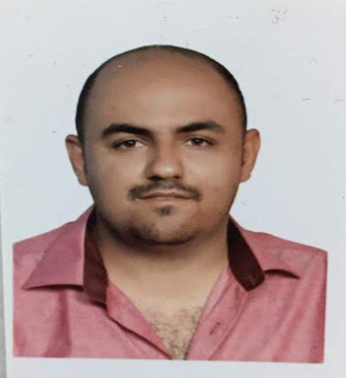

Hello

This has reference to the available vacancies in your organization. I am interested in applying for a suitable opening in any of the following areas in your organization:-

I administrative support supervisor with 9 years’ experience in management, HR, inventory and production in addition to sales coordination.

• Computer Skills including Key Application, Computer fundamentals, living online

• Operations including Administration, Human Resources & Industrial relations

• Logistics/Warehouse management

• I have a practical working experience of over nine years in operation machines at various levels. Started from employee on one machine and develop to be sales manager and Warehouse management.

This is a short description about me. More details have been mentioned in detailed Curriculum vitae in the following pages. In case you need any more information, please feel free to write back to me.

I hereby assure you the best of our services.

(Mostafa loay)

Erbil

Dated: 04.04.2019

Mostafa Loay

, 100 m - Janar Street – Erbil - Iraq

Phone – +9647512588125

Email – mostafadaban@gmail.com

Career Objective:

To succeed in an environment of growth and excellence and earn a job which provides job satisfaction, self-development and helps me to achieve personal as well as organizational goals.

Career Advancement:

Good work and enough experience will lead to greener pastures. They will be considered to be a part of the high level management, where they are entitled to receive large salaries, bonuses and perks

Academic Qualifications:

|  |
| --- |
| Erbil Polytechnic University (2008 – 2010) |
| Bachelor in the banking and financial specialization Cihan University **(**2018**)** |
| A certificate of appreciation in teaching summer students in Erbil Polytechnic University (2016) |

Work Experience:

|  |  |  |
| --- | --- | --- |
| Duration | Organization | Designation |
| 2010 – 2014 | Machine Operation and Production Management | Rozhano Company |
| 2014 – 2016 | Director of External Projects |
| 2016 – 2018 | Warehouse management and timbered class manager |
| 2019 | Sales management |

Self-assessment:

Areas of Expertise

|  |  |  |
| --- | --- | --- |
| .No | Field | Self-Rating |
| 1 | Computer Skills | Very good |
| 2 | Operations (Admin/HR/IR) | Very good |
| 3 | Warehouse/Logistics Mgmt | Excellent |

Professional strengths:

• Possess excellent research based management skills.

• Ability to achieve objectives (result oriented) owing to excellent leadership skills.

• Possess excellent verbal and written communication skills.

• Ability to handle multiple tasks at the same time.

• Ability to supervise and manage administrative staff very well by virtue of applying people management.

Professional Experience (Combined for all Companies)

• Excellent skills in all corporate functions including mentoring, counseling, conflict resolution, team building, meeting deadlines, QA, communications, research, revenue generation etc.

• Very well versed with all functions related to Operations. A team player well versed with principles of Time Management, People Management & scheduling. Excellent in outstanding recovery.

• Handle Administration/HR/IR professionally.

Operating System(s)

– Desktop level - Windows 95/98,NT,2000,Vista,7,8 - SCO UNIX System V Release 3.2 Operating System(s) – High end (server level) - Windows 2000,Windows XP Professional, Windows 2003

Personal Details:

• Date of Birth: 21/07/1990

• Employment Status: Full time

• Marital status: Married

• Religion – Muslim

Job Remuneration Details:

Rozhano Company. (1000$)

Miscellaneous (Present):

|  |  |
| --- | --- |
| Facebook | Mostafa Daban |
| Instagram | Mostafa Daban |
| E-mail | [mostafadaban@gmail.com](mailto:mostafadaban@gmail.com) |
| Nationality | Iraqi |

Languages known:

|  |  |  |  |  |
| --- | --- | --- | --- | --- |
| No | Language | Read | Write | Speak |
| 1 | Arabic | Fluent | Fluent | Fluent |
| 2 | Kurdish | Good | Good | Very good |
| 3 | English | Good | Good | Good |

I hereby confirm that details mentioned above are true to the best of my knowledge.

( Mostafa loay )